**Mini Project**

**RCA-451**

**Synopsis on**

**SMART TRAFFIC MANGAEMENT SYSTEM**

**Submitted to: Ms. Shivani Dubey**

**Submitted by: Sumit Singh**

**Roll No: 1809114025**



**JSS MAHAVIDYAPEETHA**

**JSS Academy of Technical Education, NOIDA**

**College Code - 091**

**C-20/1 Sector-62, NOIDA, Uttar Pradesh**

1. **Introduction**

A smart traffic management system utilizing sensor data, communication and automated algorithms is to be developed to keep traffic flowing more smoothly. The aim is to optimally control the duration of green or red light for a specific traffic light at an intersection and to glow green lights for emergency services. The traffic signals should not flash the same stretch of green or red all the time, but should depend on the number of cars present. When traffic is heavy in one direction, the green lights should stay on longer; less traffic should mean the red lights should be on for longer time interval.

**1.1 Problem Statement**

In maximum cities of India people faces very heavy traffic congestion due to which very high time is consumed and there is delay in Emergency Services.I It also causes significant air pollution as well as fuel consumption/wastage.n 2014, 54% of the total global population was urban residents. The prediction was a growth of nearly 2% each year until 2020 leading to more pressure on the transportation system of cities. Additionally, the high cost of accommodation in business districts lead to urban employees living far away from their place of work/education and therefore having to commute back and forth between their place of residence and their place of work. More vehicles moving need to be accommodated over a fixed number of roads and transportation infrastructure. Often, when dealing with increased traffic, the reaction is just widen the lanes or increase the road levels. However, cities should be making their streets run smarter instead of just making them bigger or building more roads.

**1.2 Scope of Project**

**1.Existing Scenario**

The exiting traffic system is generally controlled by the traffic police. The main

drawback of this system controlled by the traffic police is that the system is not

smart enough to deal with the traffic congestion. The traffic police official can

either blocks a road for more amount of time or let the vehicles on another road pass

by i.e. the decision making may not be smart enough and it entirely depends on

the official’s decision. Moreover, even if traffic lights are used the time interval for

which the vehicles will be showed green or red signal is fixed. Therefore, it may

not be able to solve the problem of traffic congestion.

1. **Proposed System**

The first and primary element of this system is the wireless sensor nodes consisting of sensors. The sensors interact with the physical environment means vehicles presence or absence while the local server sends the sensors data to the central micro controller. This system involves the 4*2 array of sensor nodes in each way. This signifies 4 levels of Traffic and 2 lanes in each way. The sensors are ultrasonic sensors which transmits status based on presence of vehicle near it. The sensor nodes transmit at specified time intervals to the central micro controller placed at every

intersection**.**

**2.Tools and Technologies**

Tools: Anaconda, Jupyter

Technologies: Python,IoT

1. **Analysis Documents**

**3.1ER**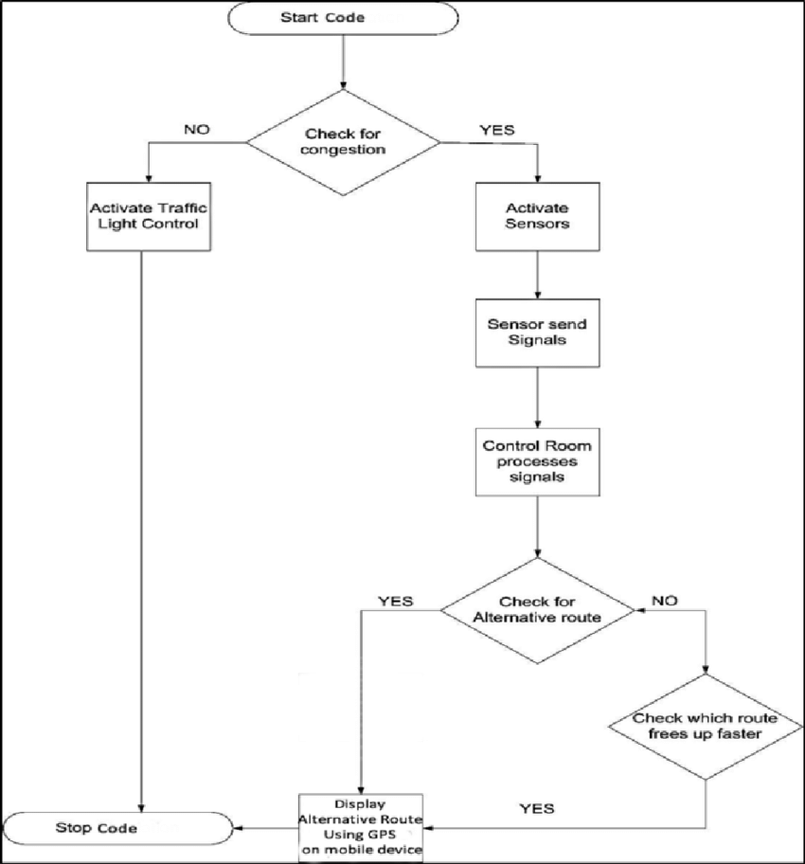

1. **Limitations**

* Money & maintenance
* Not 100% accuracy.
* Data privacy and security.

1. **Conclusion**

Smart Traffic Management System is implemented to deal efficiently with problem of congestion and perform re-routing at intersections on a road. This research presents an effective solution for rapid growth of traffic flow particularly in big cities which is increasing day by day and traditional systems have some limitations as they fail to manage current traffic effectively. Keeping in view the state of the art approach for traffic management systems, a smart traffic management system is proposed to control road traffic situations more efficiently and effectively. It changes the signal timing intelligently according to traffic density on the particular roadside and regulates traffic flow by communicating with local server more effectively than ever before.Traffic optimization is achieved using IoT platform for efficient utilizing allocating varying time to all traffic signal according to available vehicles count in road path. However, we can further design new maps with the help of these traffic lights and we will also try to create point to point path identifying on maps.

**References**

1. Smart Traffic Management System, International Journal of Computer Applications (0975 – 8887) Volume 75– No.7,August 2013-19 Smart Traffic Management System Ninad Lanke B.E IT (pursuing).
2. Smart Traffic Management System Using Internet of Things, Sabeen Javaid*, Ali Sufian**, Saima Pervaiz**, Mehak Tanveer** * Department of Computer Software Engineering, College of Telecommunication Engineering, National University of Sciences and Technology, Islamabad, Pakistan.